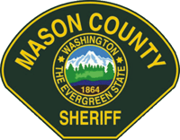
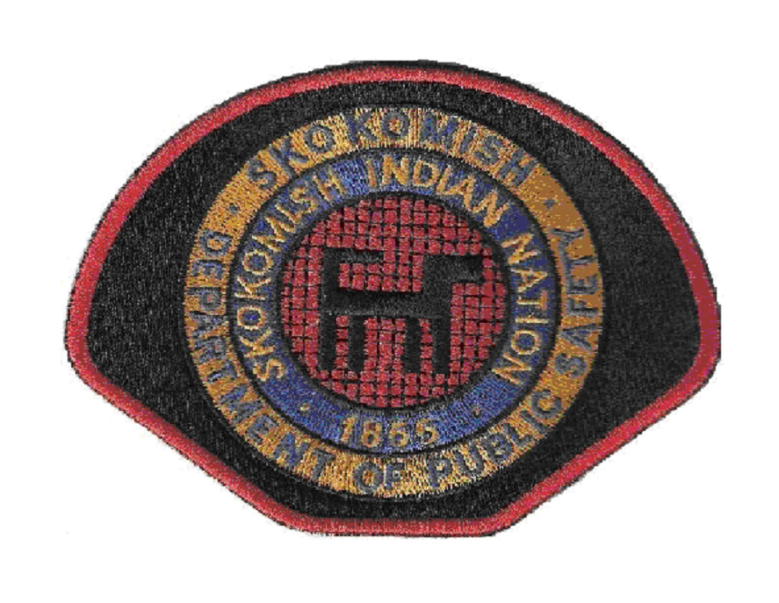

MEMORANDUM OF UNDERSTANDING
Between
the Mason County Sheriff’s Office
and
the Skokomish Department of Public Safety
Concerning
Sex Offender Registration Finger Print Submissions

1. PURPOSE

The Skokomish Department of Public Safety needs access for direct submissions for all initial Tribal Court Convictions of sex offender registration to NCIC/NSOR through the Washington State Patrol, as well as to receive any updates and notifications in order to be in compliance with the Office of Sex Offender Sentencing, Monitoring, Apprehending, Registering, and Tracking (SMART) under the Office of Justice Programs, United States Department of Justice.

The Washington State Patrol is unable to accept Tribal convictions for the purpose of sex offender registration. However, a system has been put in place, which allows for the information submission, which bypasses the State repository. As it is cost prohibitive and an unreasonable burden to require the Skokomish Tribe to establish a stand alone ACCESS terminal for this task the Mason County will provide this entry to assist the Skokomish Tribe in complying with the SMART requirements.

2. AUTHORITY
For the Skokomish Department of Public Safety:
- The Adam Walsh Child Protection and Safety Act of 2006
- Public Law 109-248
- Sec. 127 (42 U.S.C. § 16927)
- Skokomish Tribal Code §§ 9.02.A–9.02B

For the Mason County Sheriff’s Office:
- RCW 9A.44.130

3. SCOPE

This MOU applies only for the Mason County Sheriff’s Office to directly submit all initial Tribal Court conviction sex offender registration to NCIC/NSOR via the Washington State Patrol.

NOTE: Non-Tribal convictions are already completed by the Mason County Sheriff’s Office on all initial sex offender registration, but an MOU is requested to be in place in order for the Skokomish Department of Public Safety to show that they are in compliance.

4. ADMINISTRATION

Since the process of submitting all initial sex offender registration to include finger print submissions to the Washington State Patrol is already being completed for all sex offenders registering within Mason County; no extra time, work, manpower hours, or equipment usage and supplies are needed.

5. RESPONSIBILITIES

Under RCW 9A.44.130, all persons convicted of a sex offense listed in that chapter are required to register within the county of their residence. All initial sex offender registration will be completed and submitted to NCIC/NSOR through the Washington State Patrol. This MOU will not change that process. This MOU will only show that all initial non-Tribal Court sex offender registration(s) finger print submission(s) will be handled by the Mason County Sheriff’s Office. Tribal Convictions will be entered into NCIC/NSOR via the WSP “workaround” by the County and the Tribe will be responsible for submitting fingerprints via the FBI procedure. This MOU requires the Tribe to notify offenders convicted in Tribal Court of their responsibility to register with the County as a foreign conviction as required under RCW.

6. COORDINATION

The Mason County Sheriff’s Office Sex/Kidnapping Offender Registration Coordinator or his/her designee will conduct the initial sex offender registration for all non-Tribal convictions, submit the fingerprint submissions to NCIC/NSOR through the Washington State Patrol and forward any registration information to the Skokomish Department of Public Safety if that registrant will reside, work, or attend school on the Skokomish Reservation land. The Skokomish Department of Public Safety will handle initial registration for all Tribal Court convictions of sex offenders, including providing notice of the offender’s duty to register with Mason County as a foreign conviction. The Skokomish Department of Public Safety will provide the Mason County Sheriff’s Office with all required registration information, which the County will enter into NCIC via the WSP “workaround.”

7. PARTIES

- The Mason County Sheriff’s Office
- The Skokomish Department of Public Safety

8. LIABILITY

Each agency is responsible and liable for the acts and omissions of its own officers, agents or employees in connection with the performance of their official duties under this MOU.

9. REPORTING STATISTICS

The Mason County Sheriff’s Office is required to make quarterly statistic reports to the Washington Association of Sheriff’s and Police Chief’s (WASPC) due to the Sex Offender Face-To-Face Grant. This MOU will not change that responsibility.

10. TRAINING

The Mason County Sheriff’s Office can, when available, to provide specialized training by their Sex/Kidnapping Offender Registration Coordinator.

11. CONFIDENTIALITY

It is understood that any confidential information pertaining to Sex Offender Registration will be held in the strictest confidence, and will only be shared with law enforcement agencies where necessary or as otherwise permitted by federal, tribal, and/or state law.

12. CONSISTENCY

No local agreement can be inconsistent with any provision herein or impair achievement of any provision herein.

NOTE: The following page will contain the effective date of this MOU as well as the signatures of the representatives from each agency with the authority to enter into this agreement.

13. EFFECTIVE DATE

This agreement shall be effective on ______________________, 2013 and continue until such time as the agreement is canceled by either party upon written notice delivered to both agency directors.

Entered into this ____ day of ________________, 2013.

_____________________________________________
For the Mason County Sheriff’s Office

_____________________________________________
For the Skokomish Department of Public Safety

