Selah Police Department
617 South 1st Street • Selah, Washington 98942
Business (509) 698-7347 •Fax (509) 698-7362
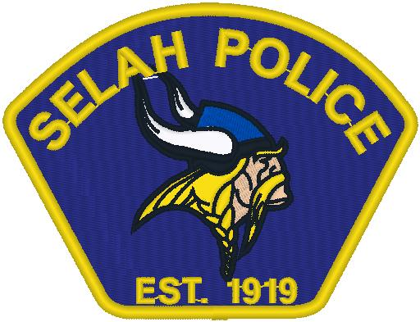

Entry and Lateral Police Officer

Each person with a desire to work for the City of Selah’s Police Department must complete the application process to be considered.

Applications can be found on-line at:

https://selahwa.gov/human-resources/employment-opportunities/

Employment applications for current openings can be submitted in person and by mail to: Selah City Hall, 115 West Naches Ave, Selah, WA 98942; or emailed to: monica.lake@selahwa.gov

Entry and Lateral Police Officers

- Must be a citizen of the United States
- Must be able to read and write the English language
- Must be in good health and good moral character
- Possess a valid driver’s license
- Must pass a written examination, physical ability/performance test, pre-selection interview, polygraph, psychological and medical examinations drug screening, and a comprehensive background investigation regarding applicant’s aptitude, character, judgment, credit, driving record and criminal history.

Education Entry Level Police Officer

- High school diploma or equivalent.

Education Lateral Police Officer

- High school diploma or equivalent.
- Completed the Washington State Criminal Justice Training Academy or an academy which is recognized by the State of Washington as an equivalent.
- Must be employed with a law enforcement agency and have completed one (1) year of service in good standing with current agency.

Full Time Benefits
- Holiday, vacation & sick days accrued
- Personal and family medical insurance premiums paid by employer 100%.
- Personal and family vision and dental insurance premiums paid by employer 100%.
- Participation in an HRA VEBA program with employer contribution.
- Employee Assistance Program (EAP) for employee, spouse, and dependents.
- Option to participate in Washington State Deferred Compensation Program (DCP).
- Option to participate in discounted Aflac Group rates.

