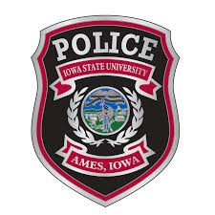
IOWA STATE UNIVERSITY POLICE DEPARTMENT
The Iowa State University Police Department is accepting applications on an ongoing basis for qualified individuals looking for a challenging and rewarding career to fill open positions for Police Officer II. Certification from the Iowa Law Enforcement Academy as a police officer or a law enforcement certificate from another state and successful completion of all application and examination requirements as outlined in Iowa Administrative Code 501-3.8(80B).

Required Minimum Qualifications:
- Prior certification from the Iowa Law Enforcement Academy or comparable out-of-state academy is required.
- Valid U.S. driver's license
- High school diploma or GED equivalent

Preferred Qualifications:
- An associate’s degree in a criminal justice related field or a bachelor’s degree in any field

Benefits:
- Tuition reimbursement after one year of service
- All uniforms and academy expenses provided by employer
- Specialty assignments include: investigations, threat assessment, special events, equity and inclusion officer, community outreach specialist, emergency response team, recruiting and retention team member, sexual assault response team and more
- Competitive health, dental, vision, and life insurance
- Employer contributed retirement options
- Extensive overtime assignment opportunities
- Wellness program to include membership at several local fitness centers
- Pay begins at $50,472 with the ability to increase to Police Officer III at $52,756

Learn more about ISU Police here: https://www.youtube.com/watch?v=7mf1KORyo_c

Apply today! Please go to https://www.police.iastate.edu/about-us/employment-opportunities/ or contact Lt. Jenna Whiteaker at 515-294-2941 or jennaw2@iastate.edu

All qualified applicants will be invited to take a written test and physical test with dates to be determined based on applicant availability.

