February 23, 2022
Greetings from your Executive Director:

“Cutoffs”, the point at which certain bills must be passed to stay alive, are coming and going during this time in the legislative session. Two bills that relate directly to investigatory detention and use of force, SB 5919 and HB 2037, are still being considered. Another “cutoff” comes this Thursday.

Legislative Progress

The fact that both SB 5919 and HB 2037 passed with strong bipartisan support shows that the legislature is paying attention to victims of crime. Here is the link to watch the entirety of the discussion on SB 5919 and its various amendments.

The discussion on the Senate Floor pertaining to SB 5919 is approximately one hour in length. (See 1:12:30 to 2:17:15.) The Senate considered a handful of amendments, some adopted and others rejected. One noteworthy amendment was Senator Wagoner’s amendment to re-add vehicular pursuit language, which was adopted by a majority vote and included in the vote on final passage. Throughout the floor discussions, several senators took time to remark on the various amendments and the final bill. These remarks are important to hear because they shed light on the very complicated political dynamics that go into producing a strong, bipartisan bill.

SB 5919 passed the Senate 31-18. The majority included 9 Democrats and 22 Republicans. If you would like to hear the roll call, skip to the final couple minutes of the clip.

Based on your feedback, there are three main issues we continue to focus on in the remaining weeks:
- A definition of “use of force” which is usable and clear (SB 5919 and HB 2037 both have one; we believe SB 5919 is clearer)
- Allow for reasonable suspicion and investigative detentions to embrace proactive policing (SB 5919 and HB 2037 both do this, but SB 5919 is clearer)
- Some allowance and a strong “balancing test” for pursuits. The current blanket prohibition is creating a “you can just run from the cops with no consequence” environment that results in greater danger to the public.
Chief Cammock from Mt. Vernon PD sent along this letter that was submitted to their legislators regarding the need for a change in the law to reduce the current environment about prohibiting pursuits, which has a great message and provides a specific example. I am sending it along with his permission.

On a different but very important note: SB 5841 would provide for a local option sales tax to be used for public safety staffing. The bill would not increase local sales tax, as the funds would be diverted from going to the state. It is worth noting that this week, revenue forecasts for the next two years are $2.7 billion higher than projected.

Washington State is 51st in the nation in staffing and has been for 11 straight years. Staffing levels are even lower than they were last time we got official numbers, which still put us last. Current confusion and lack of support is causing reduced staffing, and we need more staffing to carry out de-escalation when possible, achieving the goals of “teaming up and slowing down” and safely handling workloads. All of you are also aware that safety is enhanced when officers and deputies are not fatigued, not working excessive mandatory overtime, and not working with little to no supervision. For all these reasons, it makes sense for the legislature to strongly support SB 5841.

Here is an article from the left-leaning media platform Vox titled “Hire More Police Officers: A Popular Strategy to Reduce Crime”. In our state, this is the status quo: Fewer police, fewer prisons, more crime. Our state legislature is clearly committed to reducing prison population. Now, doing something substantive with law enforcement staffing, as SB 5841 would begin to do, would help move us toward: More police, fewer prisons, lower crime. Criminologists have called this the “double dividend”.

Media Coverage

Here is the press release and a story about the Pierce County Council supporting reform changes.

Here is the press release and a news article about an incident in Walla Walla where a driver made it clear he did not stop because of the new laws.

The Skagit County Prosecutor sent a letter to legislators that read, in part:

I am writing to express support to restore vehicular pursuits, whether under SB 5919 or HB 1788, or by some other bill. The police pursuit bill that was passed last session has not worked out in a manner that adequately protects public safety. The number of people fleeing from law enforcement has increased dramatically since the law went into effect and is a significant public safety concern. The number of people running from police has doubled or tripled in our jurisdictions, often with vehicles that have been stolen from our citizens. What law enforcement hear, if the individuals are later apprehended, is that we didn’t think you could chase us.

I am attaching a copy of a probable cause affidavit of an incident that took place this past weekend. The individual who was arrested was involved in 3 different episodes from Marysville to Stanwood to Skagit County covering 40-50 miles at speeds up to 110+MPH. I would also like to note that the individual running from the police had a significant amount of pure fentanyl when arrested and indicated to law enforcement that he threw another bag out of the window.

When finally arrested his response was that he thought we couldn’t chase people. Law enforcement need the ability to stop these individuals before we are faced with a real tragedy. Please read the affidavit and I hope you can see how dangerous things are out there for the public.

Here is a story about the rise in shootings in Spokane and features feedback directly from the neighborhoods affected. Here is the press release from Spokane PD regarding this trend.

This week, Burlington Chief Mike Luvera sent this along: “How’s this for a number: we’re up over 425 calls from this time last year. We average 20 or so reports a day (and have for 3 years). Monday we had 40, Tuesday 48 and Wednesday 51.”

Port Orchard Chief Matt Brown ran the number of stolen cars per month. From January to July 2021, the city averaged 4.6 stolen cars per month. After the new laws went into effect, they have averaged 21 stolen cars per month, including 35 in December alone.

Statewide, in January there were 4223 car thefts, the highest number since the state began tracking in 2002. This represents an increase of 1846 over last January when there were 2377.

Also this week, in Okanogan County, deputies could not detain a suspect in a double murder due to a lack of probable cause.
Here is an editorial cartoon that was featured this week in several suburban newspapers:

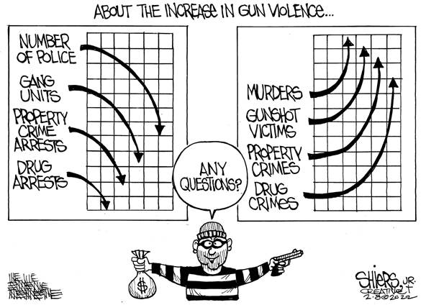

Finally, this week I saw this posting from Sgt. Eric Tung of Kent P.D. and I just wanted to pass it along as a great message for us and for our communities:

I’m talking to frustrated community members a lot. It’s actually the main part of my job now. Why did we take so long? Why wasn’t that guy arrested?

Naturally the conversation goes to new legislation, Covid, and poor staffing. Usually this frustration leads to a recognition that more cops sure would help the problems.

And usually really patient conversations- with some degree of transparency and vulnerability leads to empathy. Real communication. Lowering of walls. Heightening of collaboration.

“What can we do?” I’m asked.

Contact your legislator. They (are supposed to) work for you.

And send us your best. We all have sons, daughters, sister, cousins, uncles, friends and neighbors. A lot of em are good people. Some of them are looking for purpose, open to a change whether they know it or not.

I invite them to send them my way. I give them my card. Any talk of policing is welcome. Outreach and recruiting are the same. No conversation is wasted.

It’s up to ALL of us to make a safer community. It’s up to all of us to make a better police department.
So step up and send em.

Thank for all you do and Stay Safe - Steve

Steven D. Strachan, Executive Director
Washington Association of Sheriffs & Police Chiefs
3060 Willamette Drive NE
Lacey, WA 98516
steve@waspc.org
360-486-2380

Executive Assistant: Rachelle Harwood
rharwood@waspc.org

